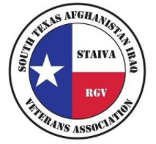
South Texas Afghanistan Iraq Veterans Association

General Assistance Program (G.A.P.)

General Assistance Program, better known as "G.A.P." was designed to assist Veterans and their families who are in need of financial assistance. The program focuses on providing financial support for Veterans and their families experiencing financial hardship who are in need of assistance with utilities, mental health, medical, transportation and/or other basic necessities when they are ineligible for any other type of assistance from other available programs in the community.

South Texas Afghanistan Iraq Veterans Association
\

General Assistance Program (G.A.P.)
Application Checklist

☐ DD-214 Member 4
☐ Copy of government issued ID (VA card, CaC card, DL, ID, Passport)
☐ Last 3 check stubs from Applicant and Spouse if applicable (if unemployed, please provide a letter of unemployment length and reason)
☐ Complete STAIVA Form 101 (Registration Form)
☐ Complete STAIVA Form 102
☐ Letter of Plan of Action for applicant in the use of funds
☐ Media Consent and Release Form
☐ Applicant Understanding

REGISTRATION FORM
STAIVA Form 101 (Please Print)
Date: |  |  |  |  |  | Registered Voter: ☐ Yes ☐ No
VETERAN INFORMATION
Last name First: Middle: |  |  |  |  |  | ☐ Mr  ☐Mrs. | ☐ Miss  ☐ Ms. |  | Marital status (circle one)  Single / Mar / Divorce / Sep / Widow
Are you a U.S. Citizen? |  | E-mail Address: |  |  |  |  |  | Birth place: |  | Birth date: |  |  |  | Age: | Sex:
☐ Yes | ☐ No |  |  |  |  |  |  |  |  | / / |  |  |  |  | ☐ M ☐ F
Permanent Address:

P.O. Box: |  |  | City: |  |  |  |  |  | State: |  |  |  | ZIP Code:
Occupation: |  |  | Employer: |  |  |  |  |  | Employer phone no.:  ( )
Ethnicity: ☐ African American ☐ Anglo American ☐ Pacific Islander ☐ Middle Eastern American
☐ Native American ☐ Caucasian ☐ Asian American ☐ Mexican American ☐ European American
☐ Other _______________
Race: ☐ Hispanic |  |  | Religion: |  |  | Education Level: |  |  | Are you currently homeless:
☐ White ☐ Black ☐ Asian |  |  |  |  |  |  |  |  | ☐ Yes ☐ No
SERVICE INFORMATION
(Please submit copy of DD-214 Member 4)
Branch of Service: |  | Type of Discharge |  |  | Start Date:  Release Date: |  |  |  |  |  | Status:  ☒ Active ☐ Reserves
 |  |  |  |  |  |  |  |  |  |  | ☐ National Guard
Are you a disabled veteran? |  | ☐ Yes |  | ☐ No | Military Job Title(s) : _________________________________________________
Campaign Badge Information: |  |  |  |  |  | Are you enrolled at a VA Clinic? ☐ Yes ☐ No If yes:
☐ OND ☐ OIF ☐ OEF ☐ Other __________ |  |  |  |  |  | ❑ Harlingen  McAllen  Other ___________________
IN CASE OF EMERGENCY
Name of local friend or relative Relationship to Veteran Home Phone Cell phone
Street Address: |  |  |  |  |  |  | City: |  | State: |  |  | Zip Code:
The above information is true to the best of my knowledge. I also authorize South Texas Afghanistan Iraq Veterans Association (STAIVA) to release my information for statistical data.
Signature ____________________________ Date _____________________
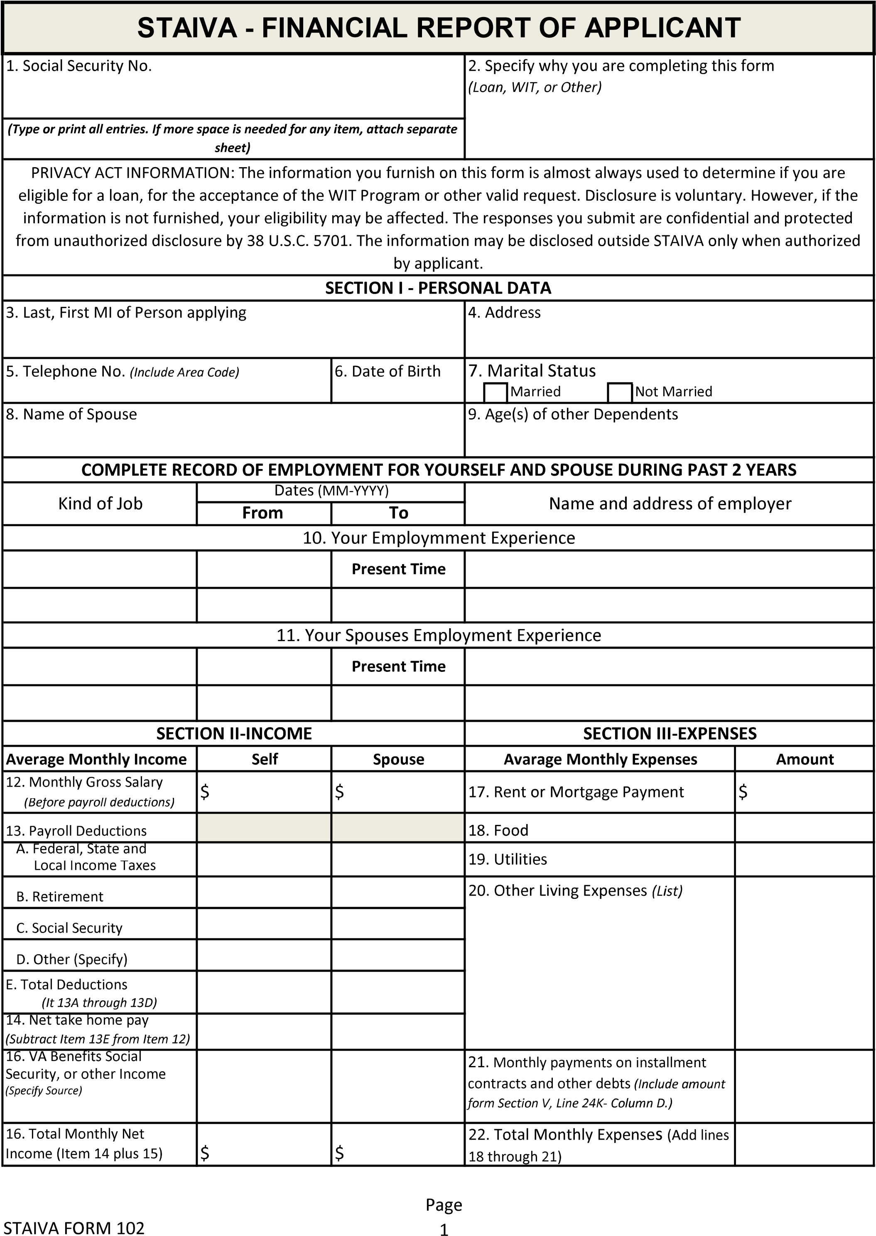
TOTAL:

South Texas Afghanistan Iraq Veterans Association

Letter of Plan of Action of applicant to use funds:

_________________________ ____________________
Signature Date

South Texas Afghanistan Iraq Veterans Association

Media Consent and Release Form

Without expectation of compensation or other remuneration, now or in the future, I hereby give my consent to South Texas Afghanistan Iraq Veterans Association (STAIVA), its affiliates and agents, to use my image and likeness and/or any interview statements from me in its publications, advertising or other media activities (including the Internet). This consent includes, but is not limited to:

- Permission to interview, film, photograph, tape, or otherwise make a video reproduction of me and/or record my voice;
- Permission to use my name; and
- Permission to use quotes from the interview(s) (or excerpts of such quotes), the film, photograph(s), tape(s) or reproduction(s) of me, and/or recording of my voice, in part or in whole, in its publications, in newspapers, magazines and other print media, on television, radio and electronic media (including the Internet), in theatrical media and/or in mailings for educational and awareness.
- I hereby release South Texas Afghanistan Iraq Veterans Association (STAIVA) and its agents from all claims which may arise out of or are in any way connected with such use.

This consent is given in perpetuity and does not require prior approval by me.

Name:
Signature:
Address:

Date:
The below signed parent or legal guardian of the above-named minor child hereby consents to and gives permission to the above on behalf of such minor child.

Signature of Parent
or Legal Guardian: Print Name:

The following is required if the consent form has to be read to the parent/legal guardian:
I certify that I have read this consent form in full to the parent/legal guardian whose signature appears above.
Staff Signature ____________________________ Date _______________________
South Texas Afghanistan Iraq Veterans Association

Applicant of Understanding

I, ________________________, am seeking assistance through the General Assistance Program (G.A.P.) and I have furnished all required documentation provided to me by _______________________, staff of South Texas Afghanistan Iraq Veterans Association (STAIVA).
(Please Initial)

______1. I understand that I will provide proper documentation to prove my expenses were used for the reason (s) stated above.

______2. I understand that proof of documents MUST be provided within 30 days from today
______3. I understand that all information provided to STAIVA is true and valid.
______4. I understand that I will actively seek courses in financial responsibility.
______5. I understand that if I fail to comply with any of the statements above, I will lose any and all future assistance from STAIVA.

Signature ____________________________ Date________________________

